using System;

using static System.Console;

namespace TestSquidWrangler

{

/*

* Console application that instantiates and displays a SquidWrangler object.

* The SquidWrangler class contains the name, id number, amount of squids

* wrangled.

*/

// Written By: Samuel Graham

// Written On: 4/12/2019

class TestSquidWrangler

{

static void Main(string[] args)

{

SquidWrangler wrangler1 = new SquidWrangler("John", 1001, 0);

wrangler1.DisplayWrangler();

WriteLine("\nJohn wrangled a squid\n");

++wrangler1.NumOfSquids;

wrangler1.DisplayWrangler();

WriteLine("\nJohn wants his last name displayed\n");

wrangler1.WranglerName = "John Squiggles";

wrangler1.DisplayWrangler();

}

}

class SquidWrangler

{

private String wranglerName;

private int wranglerId;

private int numOfSquids;

//SquidWrangler constructor

public SquidWrangler(String name, int idNum, int squids)

{

wranglerName = name;

wranglerId = idNum;

numOfSquids = squids;

}

// get or set wrangler's name

public String WranglerName { get { return wranglerName; } set { wranglerName = value; } }

// get wrangler's ID

public int WranglerId { get { return wranglerId; } }

// get or set number of Squids the wrangler has wrangled

public int NumOfSquids { get { return numOfSquids; } set { numOfSquids = value; } }

public void DisplayWrangler()

{

WriteLine("Wrangler Name: {0}", wranglerName);

WriteLine("ID Number: {0}", wranglerId);

WriteLine("Squids Wrangled: {0}", numOfSquids);

}

}

}

**OUTPUT:**

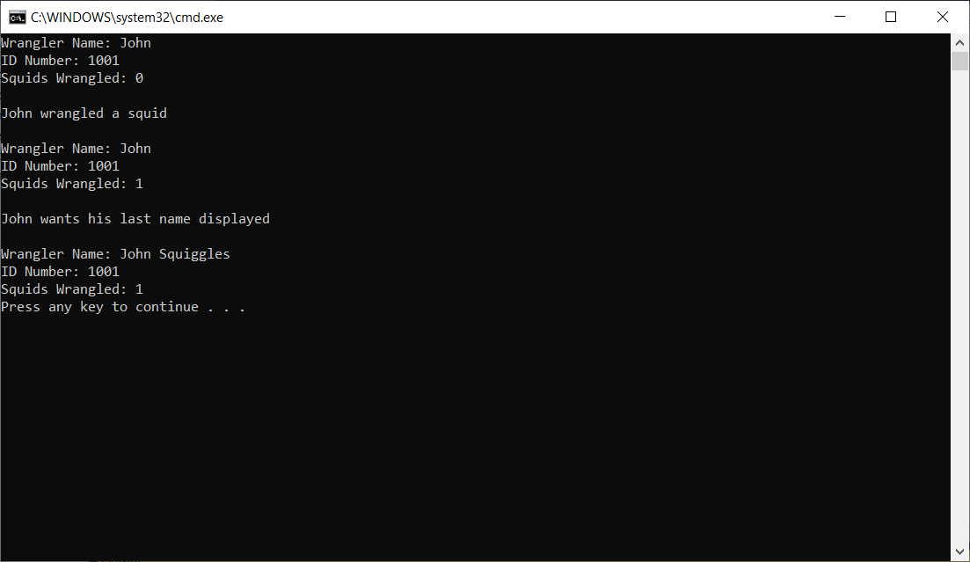

Another Program on next page.

using System;

using static System.Console;

namespace A9_COP_2360

{

/* Console application that tests and a ClassifiedAd object.

* A ClassifiedAd has fields for number of words and a price.

*/

// Written By: Samuel Graham

// Written On: 4/12/2019

class TestNewspaperAd

{

static void Main(string[] args)

{

WriteLine("Testing an ad with 20 words\n");

ClassifiedAd yourAd = new ClassifiedAd();

yourAd.NumOfWords = 20;

WriteLine("Your classified advertisement will cost {0}", yourAd.AdPrice.ToString("C"));

WriteLine("Expected outcome is ad will cost $2.20\n");

WriteLine("Testing get NumOfWords, expecting 20 words");

WriteLine("Your advertisement has {0} words\n", yourAd.NumOfWords);

}

}

class ClassifiedAd

{

// constant for price per word

const double PRICE_PER_WORD = 0.11;

private int numOfWords;

private double adPrice;

public int NumOfWords { get { return numOfWords; } set { numOfWords = value; } }

// method to calculate price

private double CalculatedPrice()

{

adPrice = numOfWords * PRICE_PER_WORD;

return adPrice;

}

public double AdPrice { get { return CalculatedPrice(); } }

}

}

